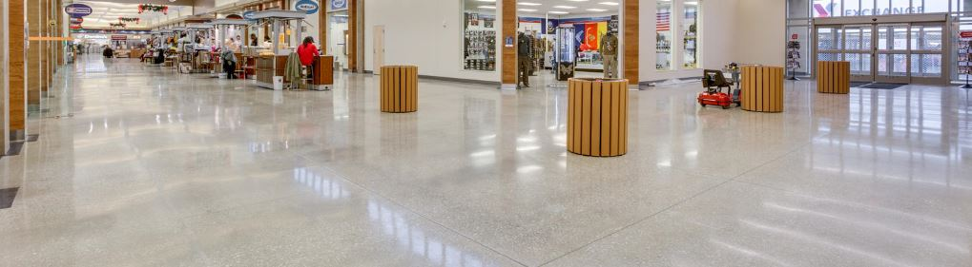

The following specification text has been prepared to assist design professionals in the preparation of a specification section incorporating a penetrating curing compound for use on decorative concrete by Skudousa.com

Utilize the following paragraphs to insert text into one of the below:

- 03 33 00 Cast-In-Place Concrete
- 03 35 43 Polished Concrete Finishing

Blue text includes instructions on product options. Black text is intended for insertion into project specifications. Red text requires input by the user.

For assistance on the use of the products in this section, contact Skudo USA by calling 888.758.3611, email at info@skudousa.com, or visit their website at www.skudousa.com

PART 2 - PRODUCTS

ACCESSORIES

Utilize the following text for specifying Skudo Cure; clear penetrating treatment for surfaces to be exposed as a floor finish. Standard Specification for Liquid Membrane-Forming Compounds for Curing Concrete ASTM.C-309 is not applicable to penetrating curing compounds that are chemically reacting in concrete.
A. Curing Compound: Single-component, clear penetrating, non-film forming curing, sealing, dust-proofing compound for interior and exterior surfaces.
- SkudoCure; Skudousa.com

