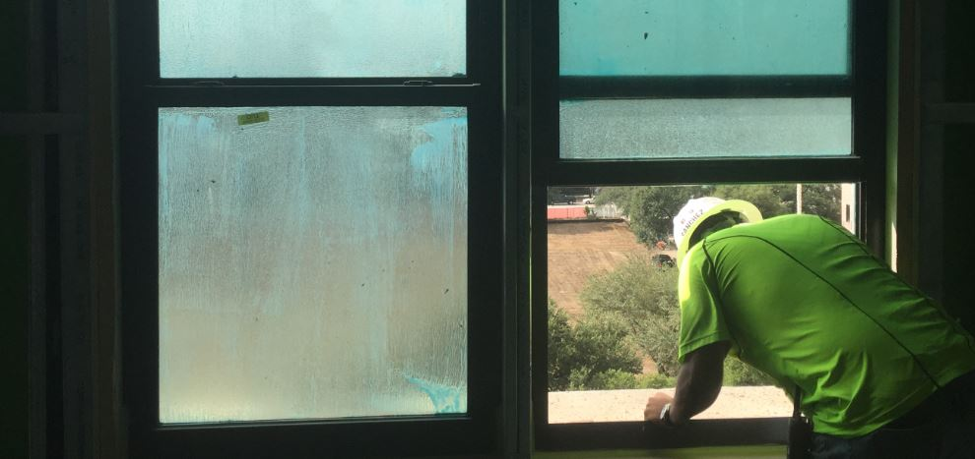

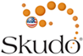

The following specification text has been prepared to assist design professionals in the preparation of a specification section incorporating temporary surface protection by Skudousa.com

Utilize the following paragraphs to insert text into one of the below:

- 07 42 13 Metal Wall Panels
- 08 88 00 Glazing

- 08 62 00 Unit Skylights
- 08 63 00 Metal-Framed Skylights

- 08 88 00 Glazing

Blue text includes instructions on product options. Black text is intended for insertion into project specifications. Red text requires input by the user.

For assistance on the use of the products in this section, contact Skudo USA by calling 888.758.3611, email at info@skudousa.com, or visit their website at www.skudousa.com

PART 2 - PRODUCTS

ACCESSORIES

Utilize the following text for specifying Glass Advanced; consisting of a liquid applied peelable film to protect surfaces for up to 12 months.

A. Temporary Surface Protection: Factory and field applied, single-component film to prevent surface damage and contamination of manufacturer approved surfaces.
- Glass Advanced; Skudousa.com

