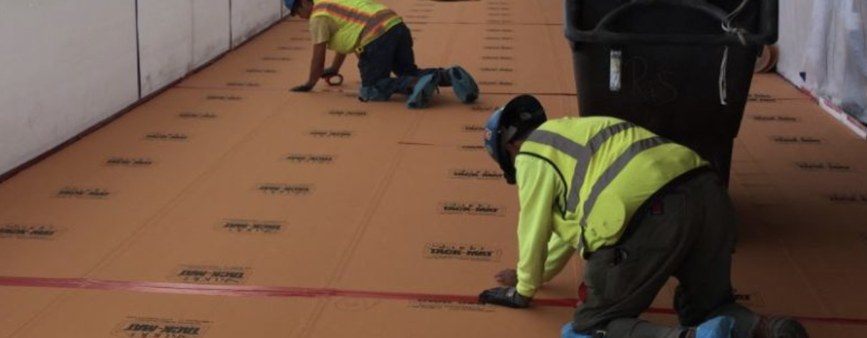

The following specification text has been prepared to assist design professionals in the preparation of a specification section incorporating temporary floor protection by Skudousa.com

Utilize the following paragraphs to insert text into one of the below:

- 03 35 43 Polished Concrete Finish
- 03 54 16 Hydraulic Cement Underlayment

- 09 30 00 Tiling
- 09 61 39 Water Vapor Emission Control
- 09 63 40 Stone Flooring
- 09 64 00 Wood Flooring
- 09 65 16 Resilient Sheet Flooring
- 09 66 23 Resinous Matrix Terrazzo
- 09 67 23 Resinous Flooring
- 09 68 13 Tile Carpeting
- 09 68 16 Sheet Carpeting
- 09 91 00 Painting

Blue text includes instructions on product options. Black text is intended for insertion into project specifications. Red text requires input by the user.

For assistance on the use of the products in this section, contact Skudo USA by calling 888.758.3611, email at info@skudousa.com, or visit their website at www.skudousa.com

PART 2 - PRODUCTS

ACCESSORIES

Utilize the following text for specifying Skudo HT Commercial System; consisting of a liquid applied base coat and a heavy-duty surface applied textured mat for exterior or interior protection for up to 12 months.

- Temporary Floor Protection: Heavy-duty, breathable, anti-bacterial, anti-fungal water repelling base coat and flexible surface textured surface mat, seam sealed to resist substrate contamination and liquids from staining substrate surfaces. Meeting Class 1 fire/ flame retardant ASTM E 648 and NFPA 253 standards.
- Skudo HT Commercial; Skudousa.com

Utilize the following text for specifying Skudo MT Commercial System; consisting of a liquid applied base coat and a medium duty surface applied textured mat for interior protection for up to 9 months.

- Temporary Floor Protection: Medium duty, breathable, anti-bacterial, anti-fungal water-
repelling base coat and flexible surface textured surface mat, seam sealed for resistance
to liquids and contaminates from staining interior substrate surfaces.
- Skudo MT; Skudousa.com

Utilize the following text for specifying Skudo Board; Heavy Duty synthetic, rigid board that provides superior exterior or interior protection under forklift, machinery, and general construction activity for extended periods.

A. Temporary Floor / Surface Protection: Heavy duty, flexible [5/16-inch thick] [7/16-inch, standard or scratch resistant fiber backed], 10 lb. per rigid sheet, textured walking surface with impact resistance of 0.9-inch when tested to ASTM D5420. Seam sealed with manufacturers adhesive tape for maximum water, stain, and spill resistance.
- SkudoBoard; Skudousa.com

Utilize the following text for specifying Skudo Tack-Mat HT; consisting of a repositionable peel-and-stick, self-adhering heavy-duty surface applied textured mat for interior protection for up to 12 months.

- Temporary Floor / Surface Protection: Heavy-duty, UV-resistant, flexible self-adhering, 1/16-inch-thick peel-and stick, textured walking surface to protect interior hard surfaces from damage and contamination. Meeting Class 1 fire/ flame retardant ASTM E 648 and NFPA 253 standards.
- Tack-Mat HT; Skudousa.com

Utilize the following text for specifying Skudo Tack-Mat HI; consisting of a repositionable peel-and-stick, self-adhering impact resistant surface applied textured mat for interior protection for up to 12 months.

- Temporary Floor / Surface Protection: High-impact, flexible, self-adhering, 1/16-inch-thick peel-and stick, textured walking surface to protect interior hard surfaces from damage and contamination.
- Tack-Mat HI; Skudousa.com

Utilize the following text for specifying Skudo Tack-Mat LT; consisting of a repositionable peel-and-stick, self-adhering light traffic surface applied textured mat for interior protection for up to 12 months.

- Temporary Floor / Surface Protection: High-impact, flexible, self-adhering, 1/16-inch-thick peel-and stick, textured walking surface to protect interior hard surfaces from damage and contamination.
- Tack-Mat LT; Skudousa.com

PART 3 - EXECUTION

FIELD QUALITY CONTROL

A. Temporary Floor / Surface Protection: Install to protect surfaces from damage and contamination until Substantial Completion. Repair and replace as required.

